Instructions for Refilling the Liquid Nitrogen and Liquid Helium for SHARCII
(J. Patience and J. Koda, March 2006)
Edited/revised by Richard, Ed, and Hiroko in December 2006

•Before starting the fill process, move the telescope to za~55 (UIP> ZA 55) so there is sufficient space

Liquid Nitrogen:
• Wear gloves and a face mask during this process.
• Fill the small white metal canister (~5L) with LN₂ from the tank located on the platform behind the AOS room. When filling the canister, keep the funnel in the top (canister) so that the funnel spout remains cold.
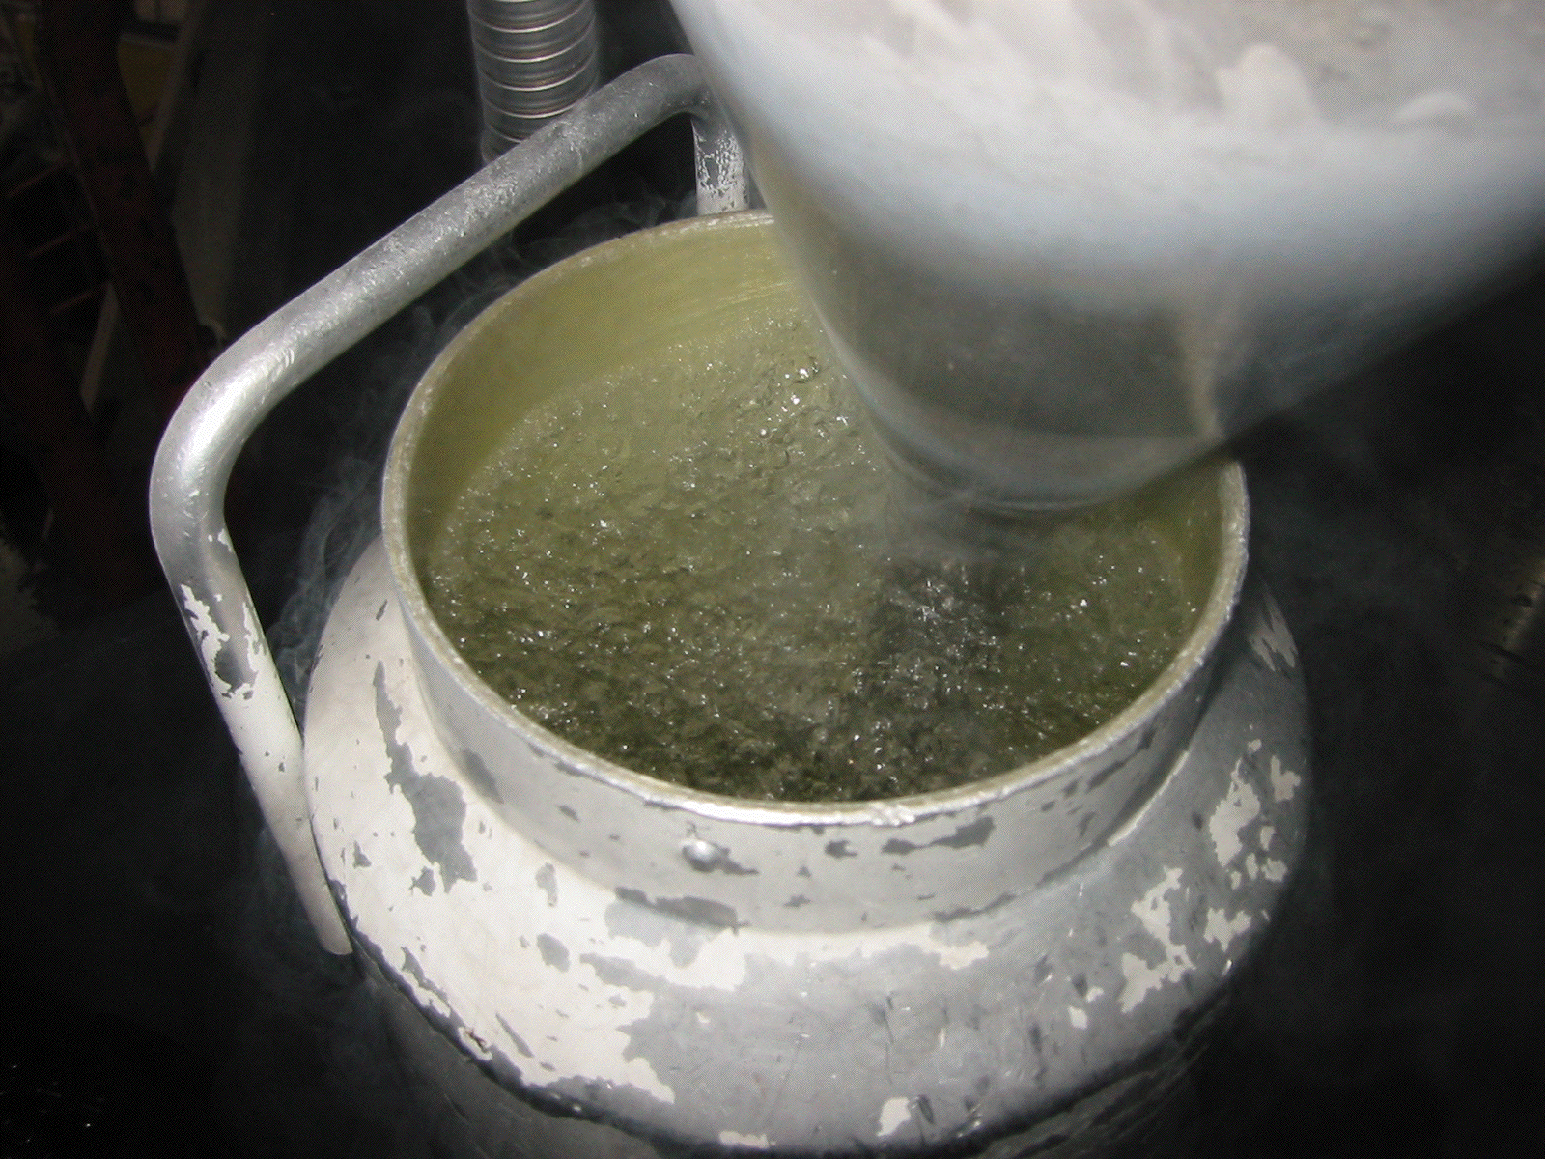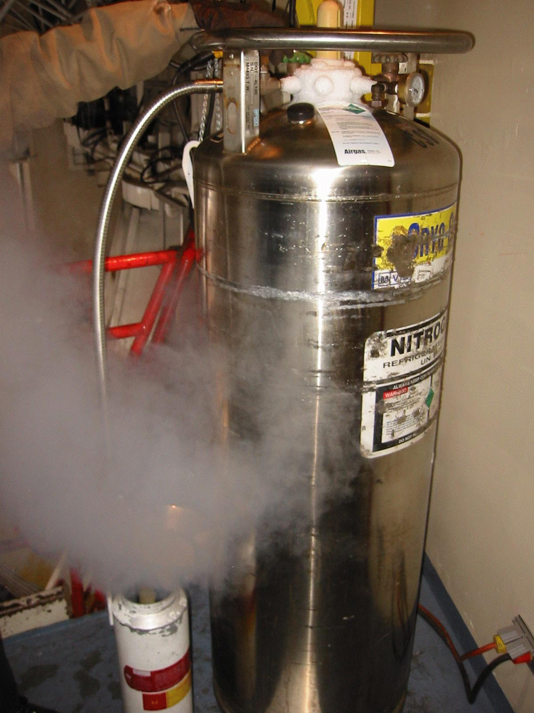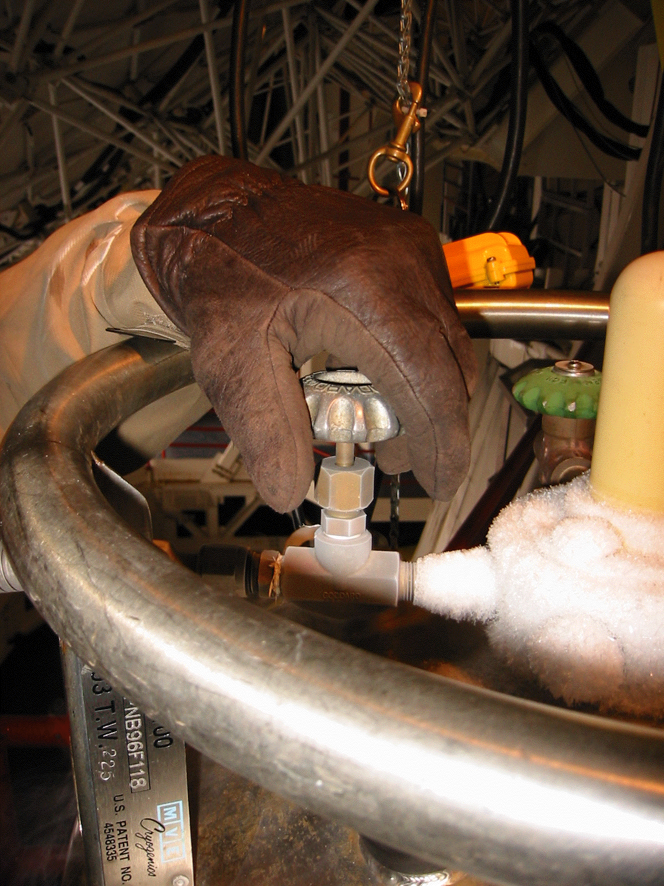
• Climb up the ladder to a step high enough to clearly see the top of SHARCII and remove the white hose labeled LN₂ and put it out of the way so that it does not freeze.
• Place the funnel in the fill hole and pour in the LN₂ until it overflows (LN2 spurts out of the LN2 fill port); this may require the entire canister.
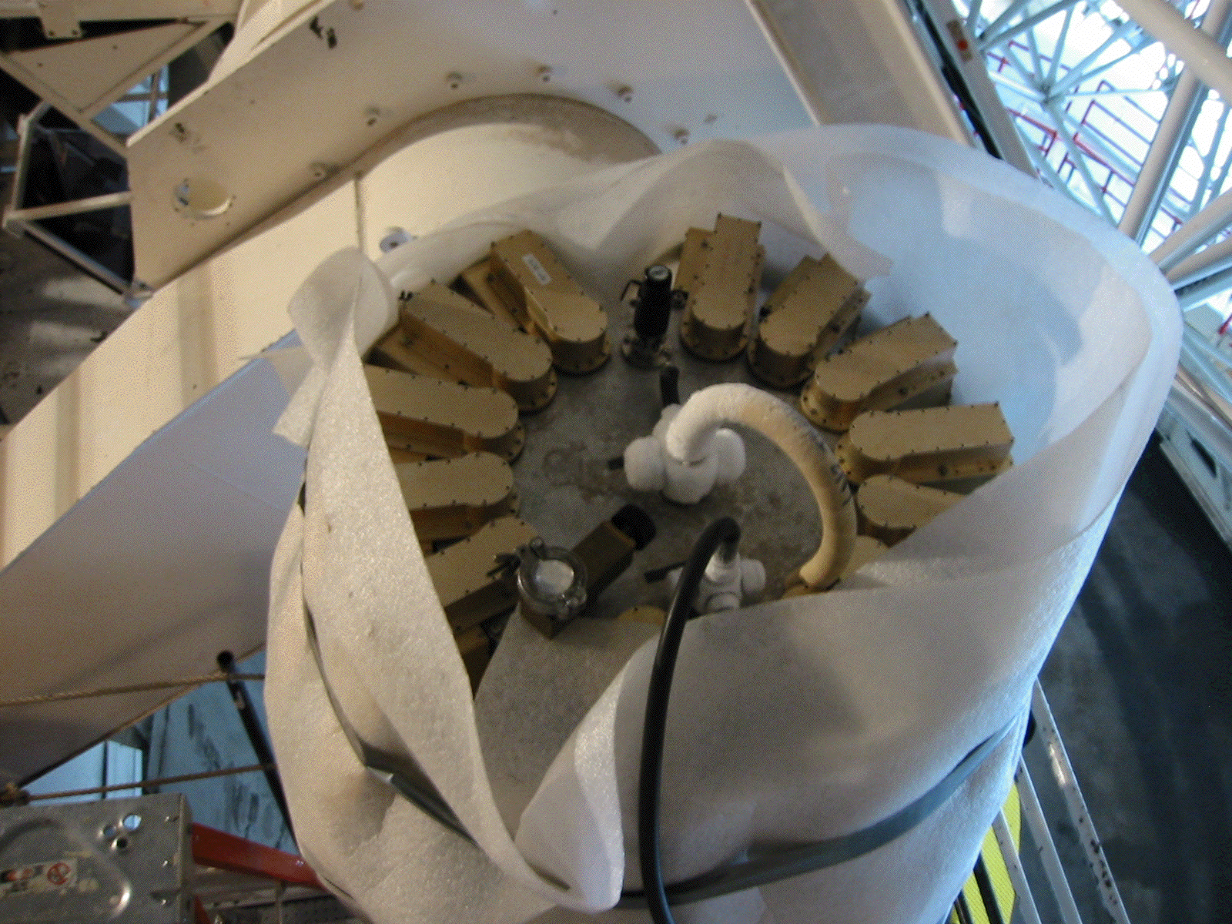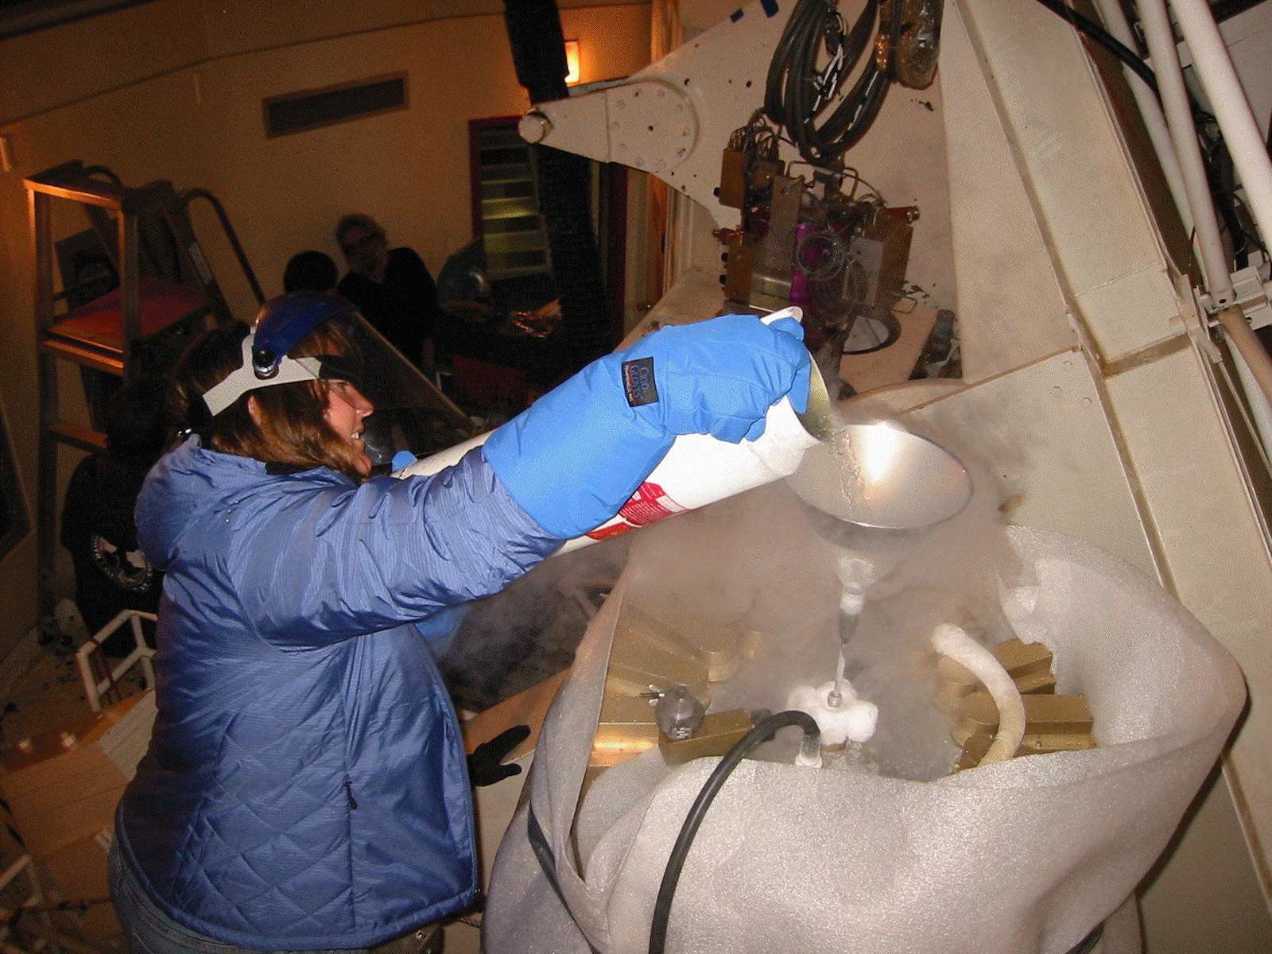
• Remove the funnel and place it in the white canister.
• After the boiling out of the fill hole stops replace the hose; using the end without frost will be easier.
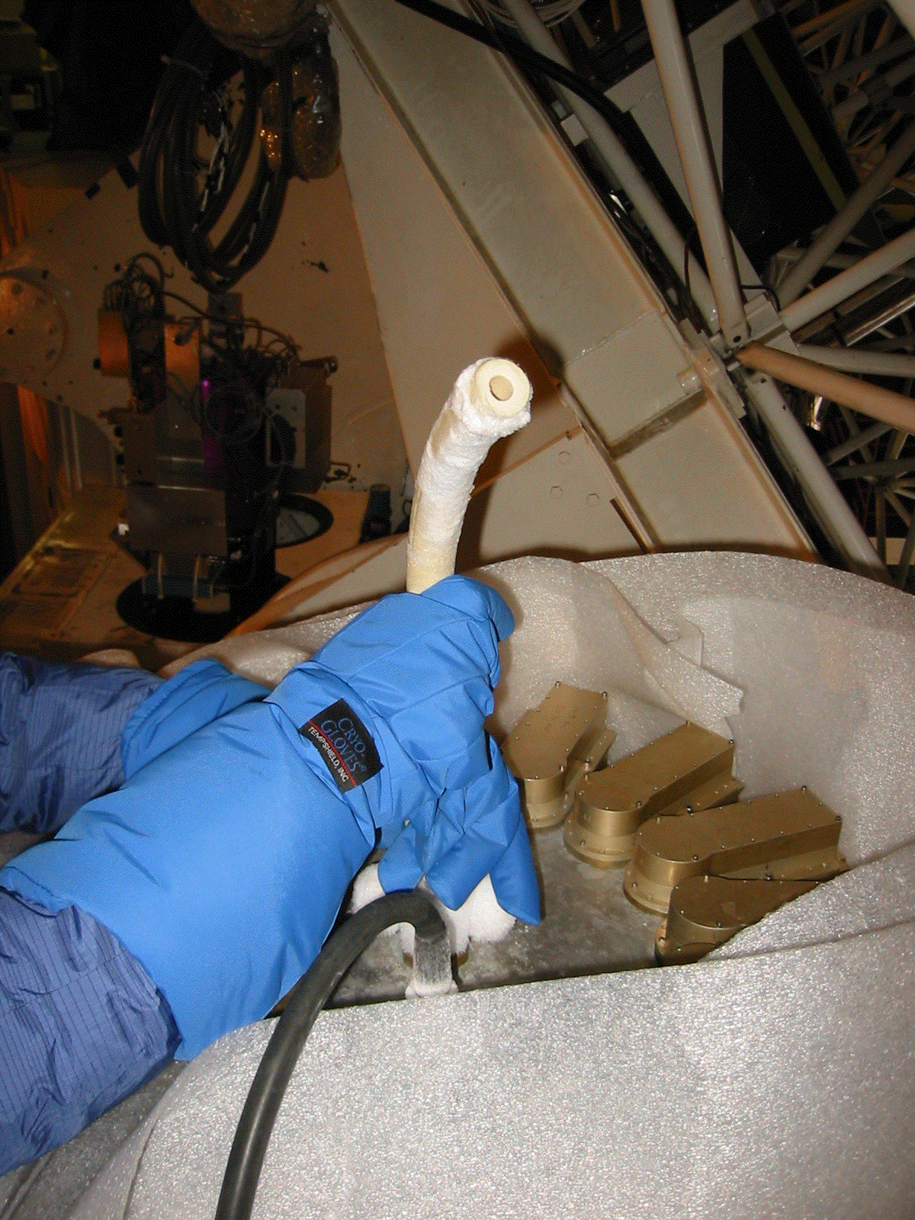
Liquid Helium:
The liquid Helium tank is located on the upper deck above SHARCII and filling the He requires one person to be at the tank and one person to be on the ladder near SHARCII.
There are three colored valve handles – 1 yellow and 2 black – and at no time should they all be closed. For the top yellow valve the open position is pointing straight up. For the black valves the open position are the handles pointing parallel to the pipes.
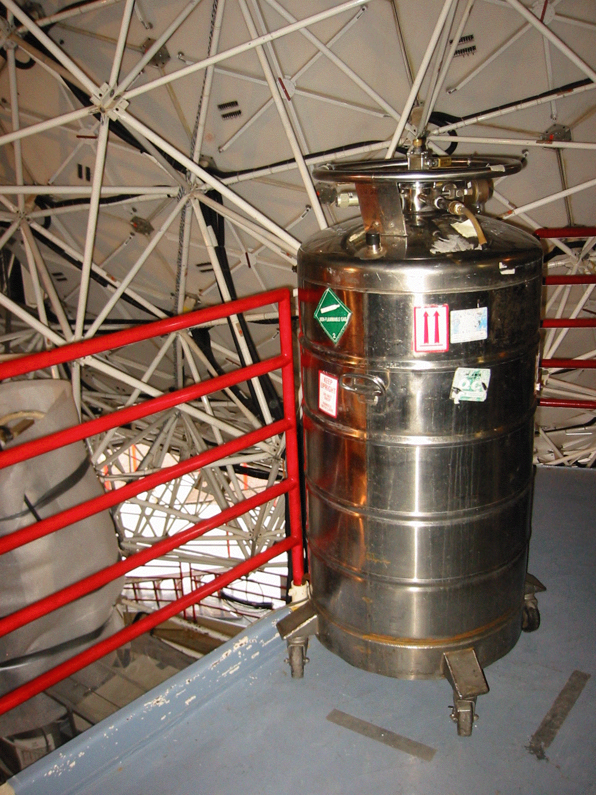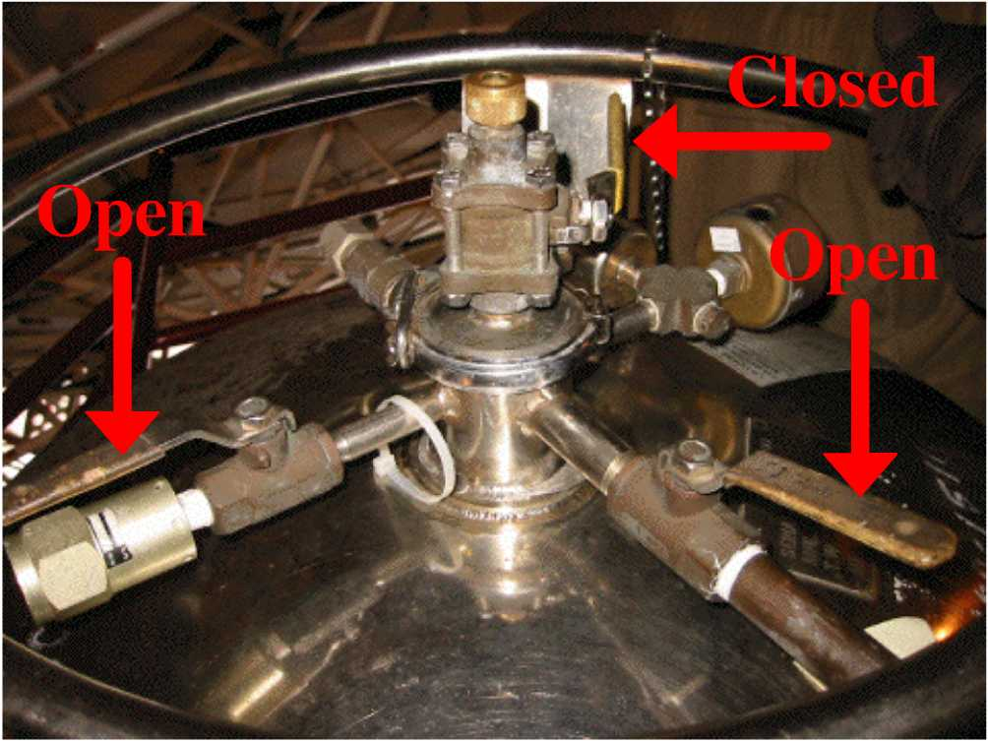
• Wear gloves and a face mask during this process.
Person at SHARCII:
• Unscrew the black vent hose for the He fill port and put the hose out of the way.

Person at the He tank:
• Open the yellow valve on the top of the tank and then close both black valves.
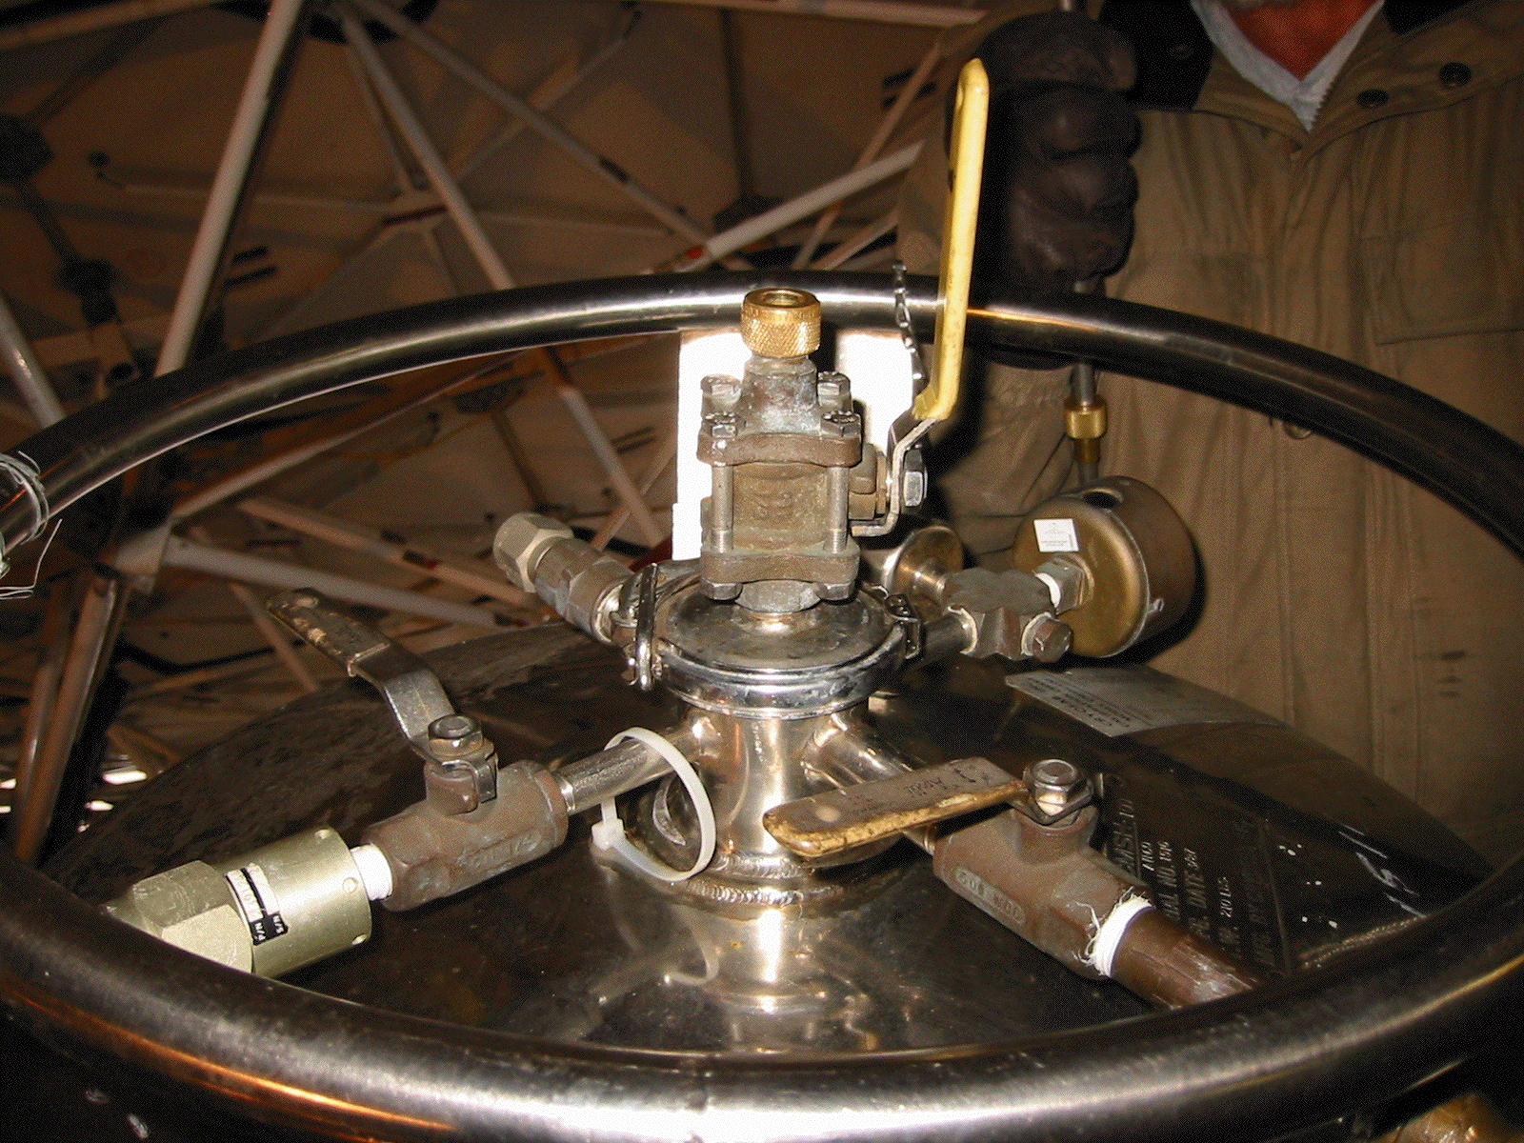
• Locate the transfer tube on the beam behind the tank and move the brass-colored metal ring to the bottom of the transfer tube and tighten the screw slightly.
• Place the brass ring of the transfer tube on top of the tank fill port.
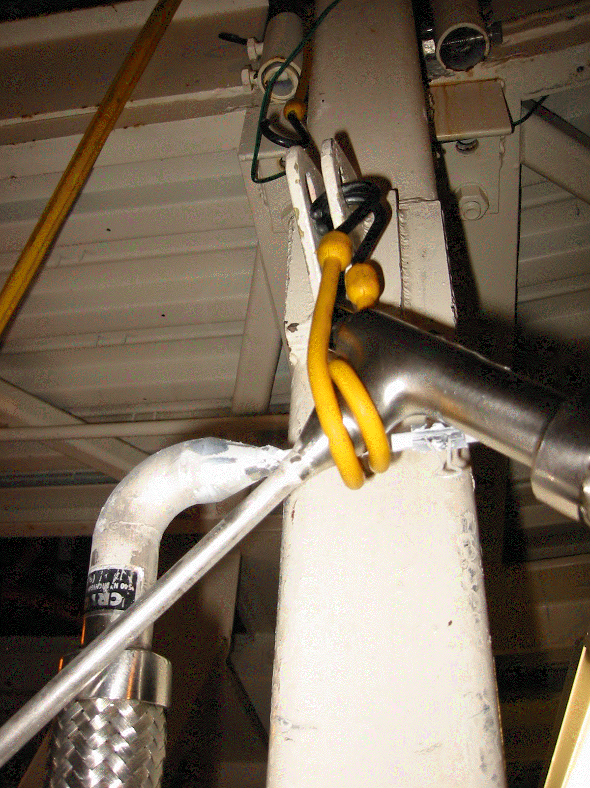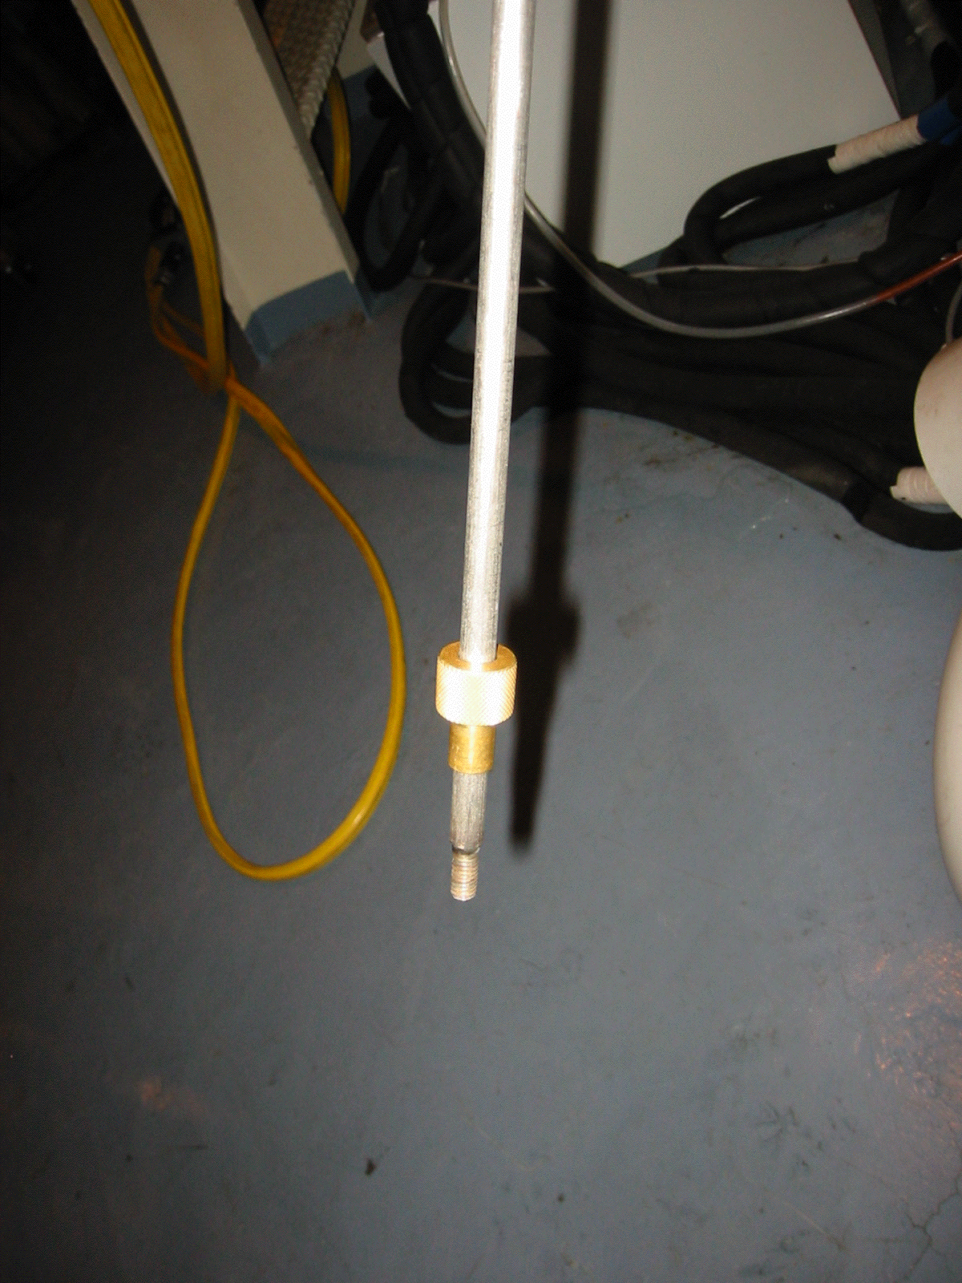

• Slowly slide the transfer tube into the He tank port; when the tube reaches the bottom of the tank, raise the transfer tube ~ ¼”, tighten the brass ring on the top of the port to hold the tube in place (wear gloves unlike the picture).
• Hand the free end of the transfer tube to the person at SHARCII.
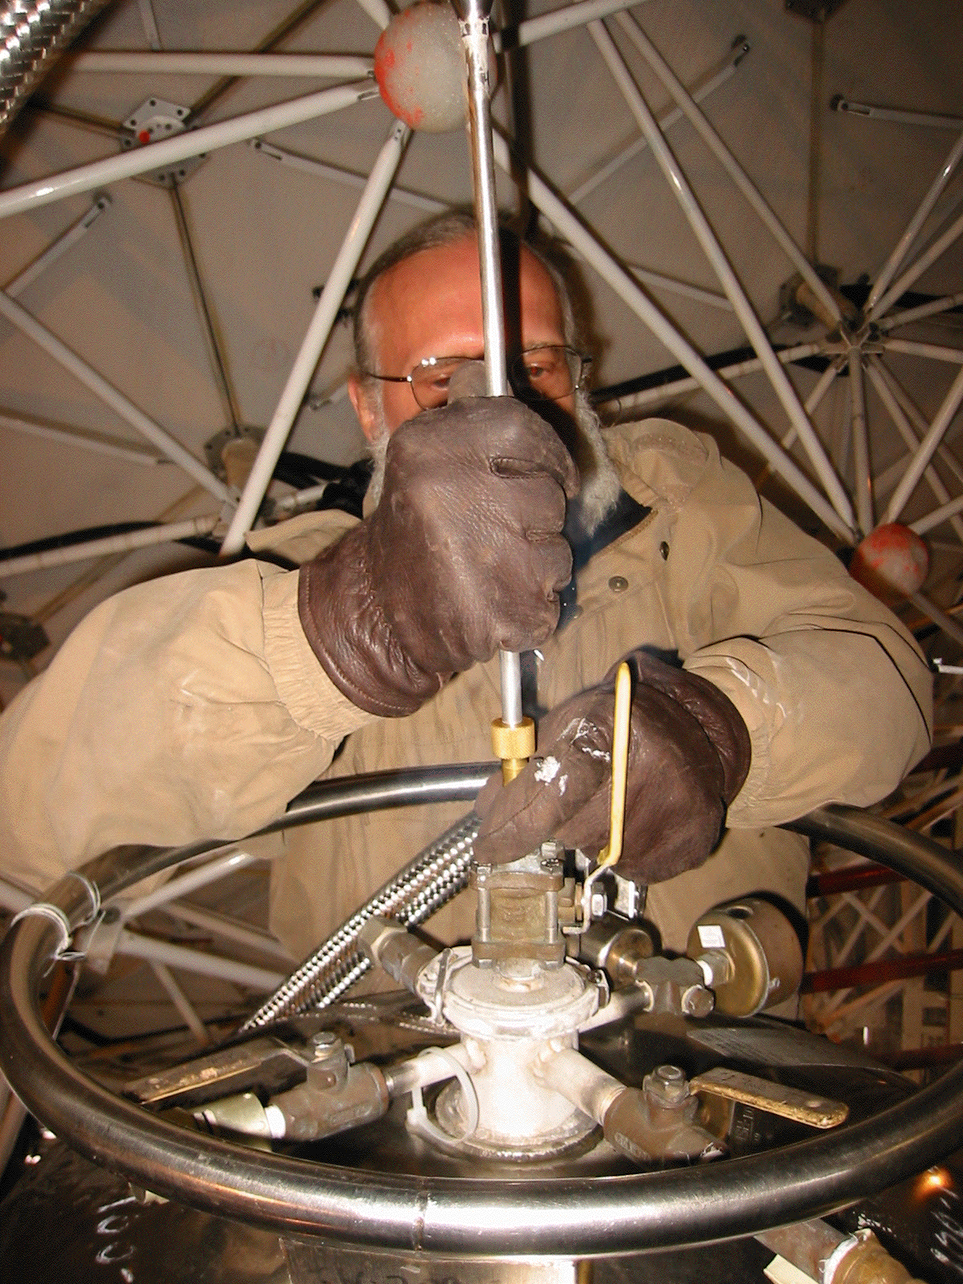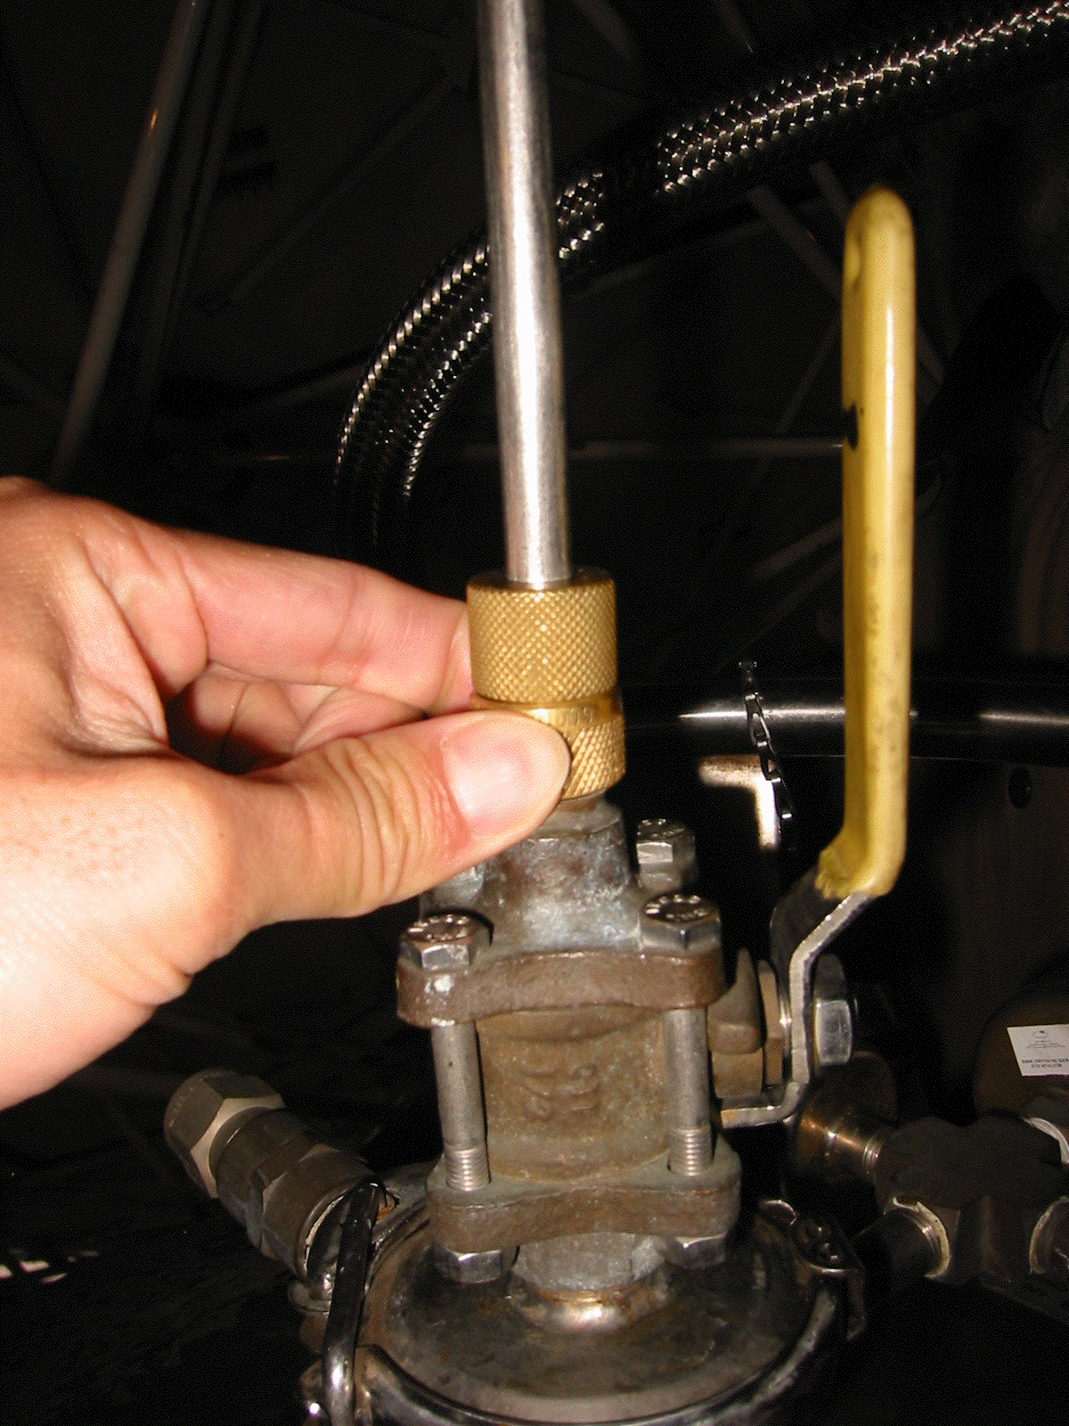

Person at SHARCII:
• Point the tube away from people/equipment and wait for a plume to appear from the end of the tube.
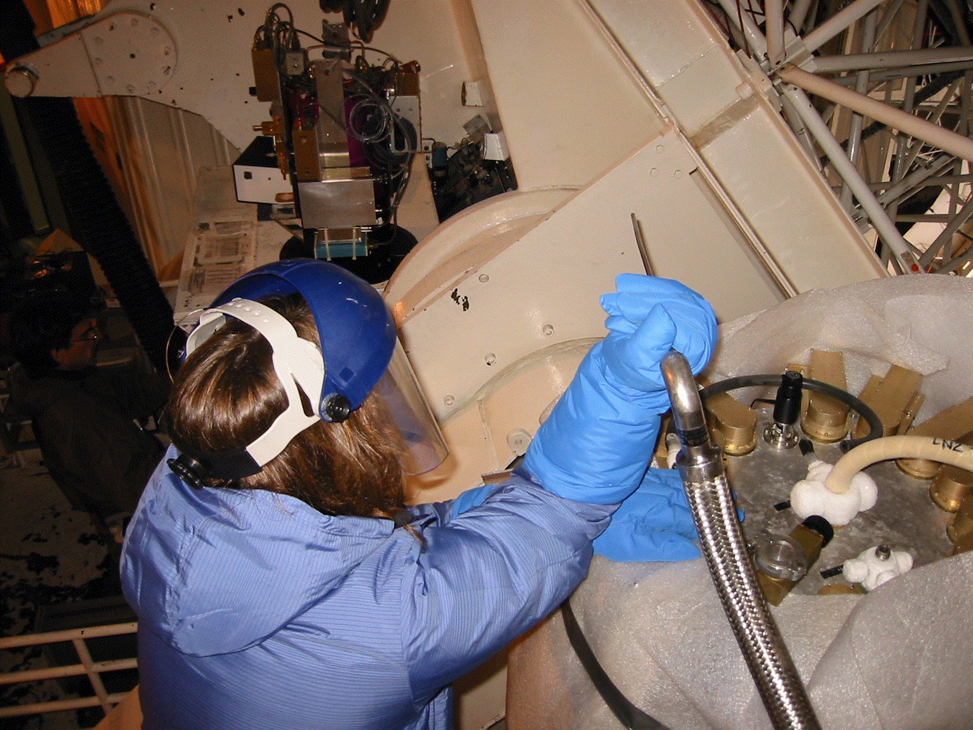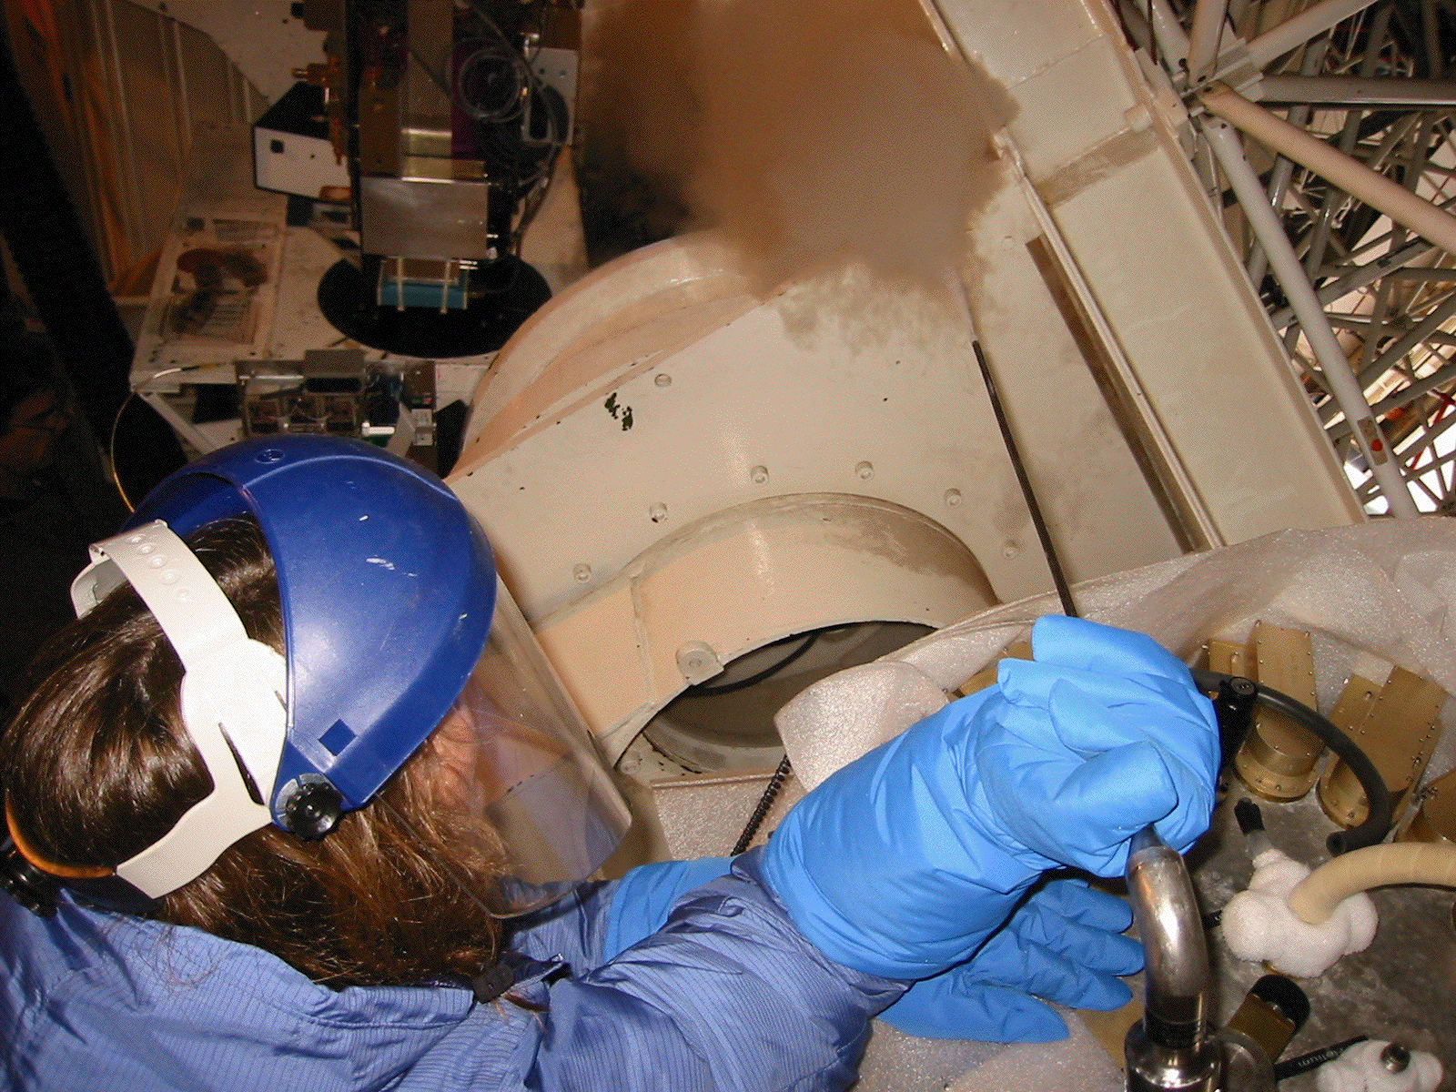
• Place the tube in the He fill port and wait until a denser, higher velocity plume rises from SHARCII.
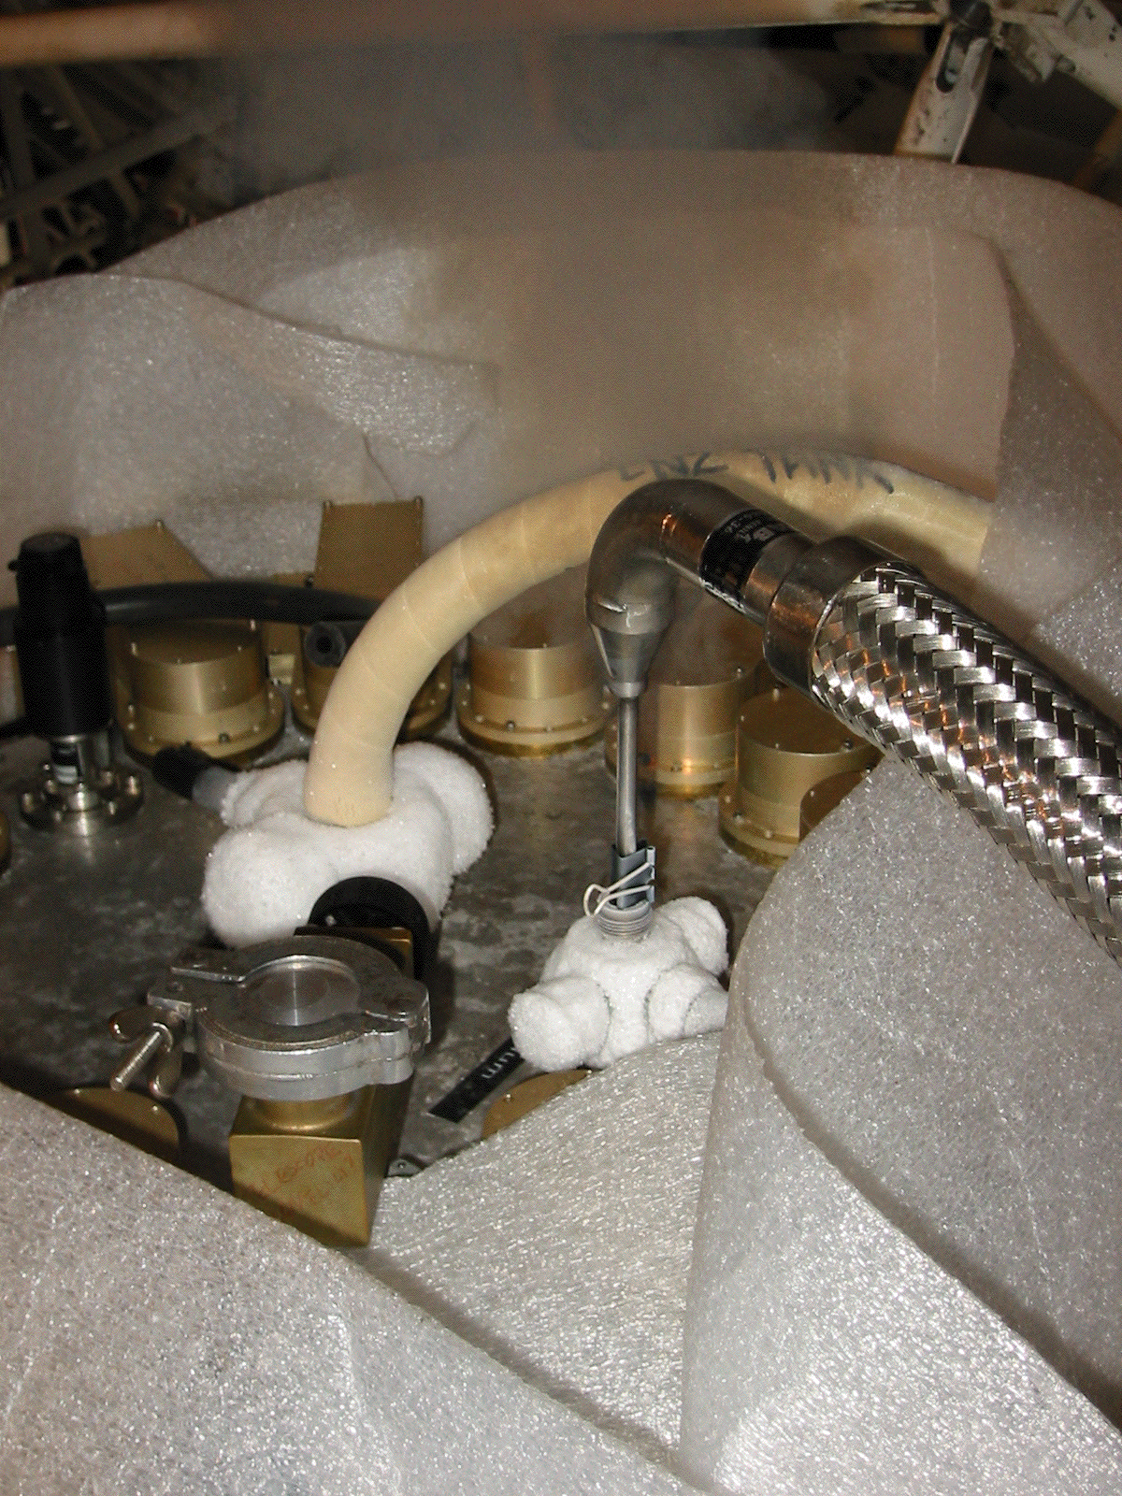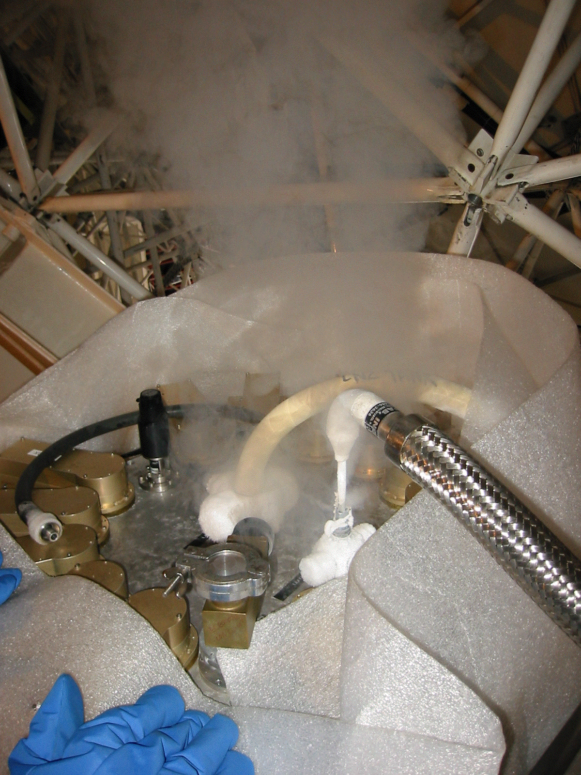
• Remove the tube and wait for the person at the LHe tank to pull their end of the transfer tube above the LH2 meniscus (but not out of the tank).

Person at the He tank:
• Open both black valves to lower the tank pressure.
• Pull out the transfer hose just high enough that only gas (not liquid) comes out of the transfer tube. Wait until He tank pressure bleeds down to about 1psi before pulling the transfer tube out
of the tank. While pulling the transfer tube out of the tank, be sure to hold down brass fitting
with one hand to avoid pulling it out and getting blasted by a flash of Helium. Be sure to wear
gloves as your hands can be easily burned by an accidental Helium flash.
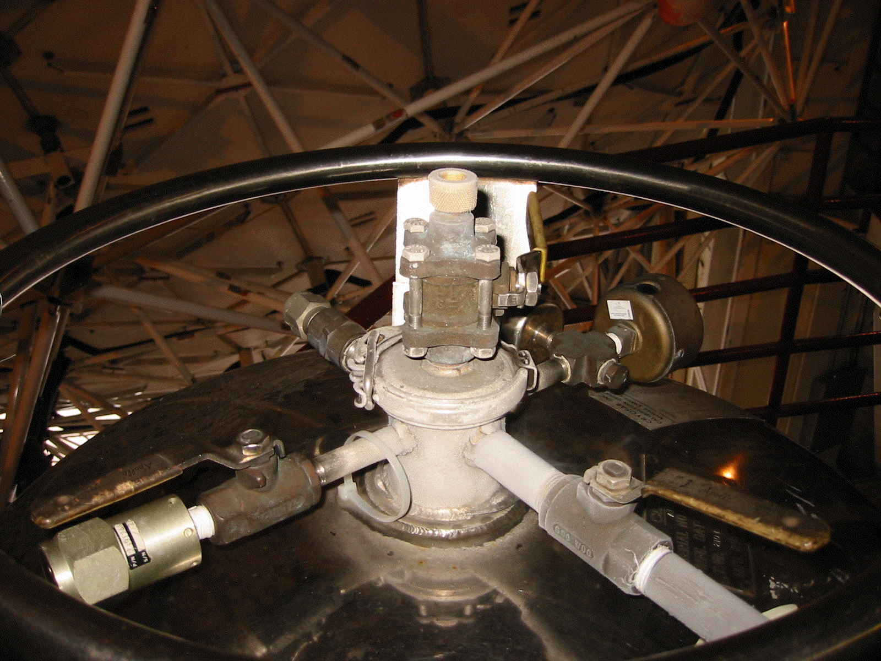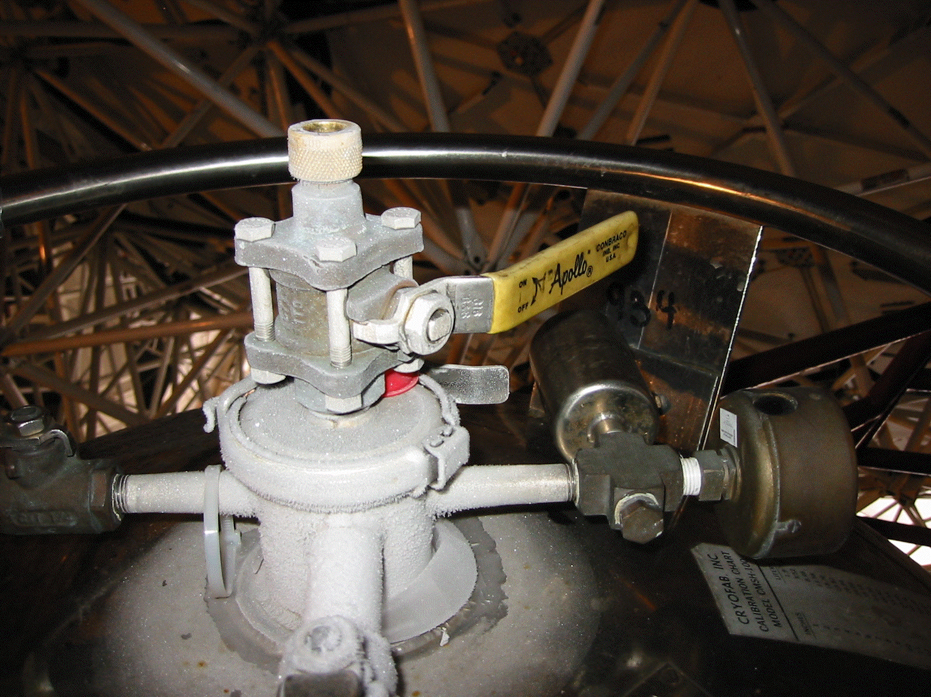
• Locate the He dipstick on the wall near the He transfer tube and remove the lower alligator clip.
• Briefly open the yellow valve and insert the dipstick into the port until you reach the bottom of
the tank. Attach alligator clip and raise the dipstick until the sound frequency changes to a significantly higher pitch. Reattach the second alligator clip and remove the dipstick. Measure the length between the clips and record on the clipboard attached to the He tank.
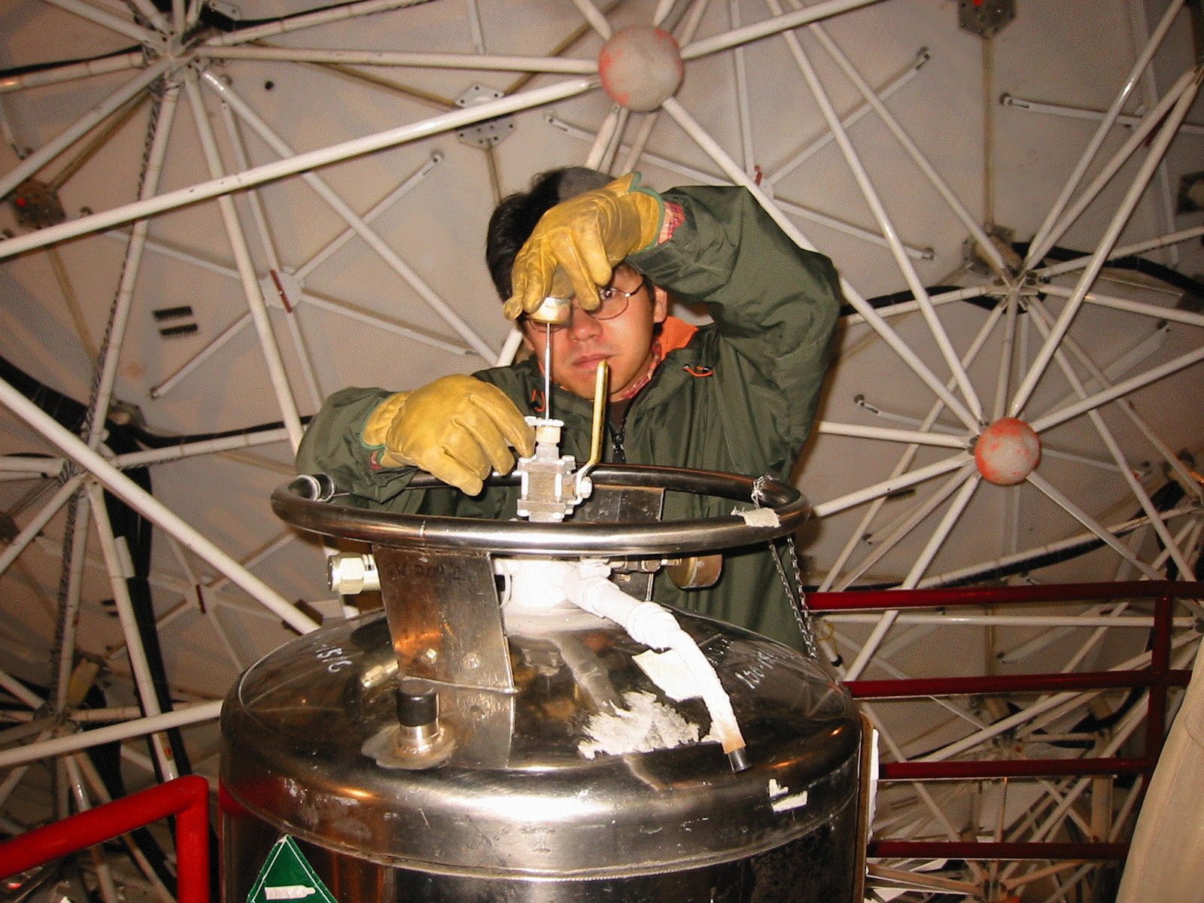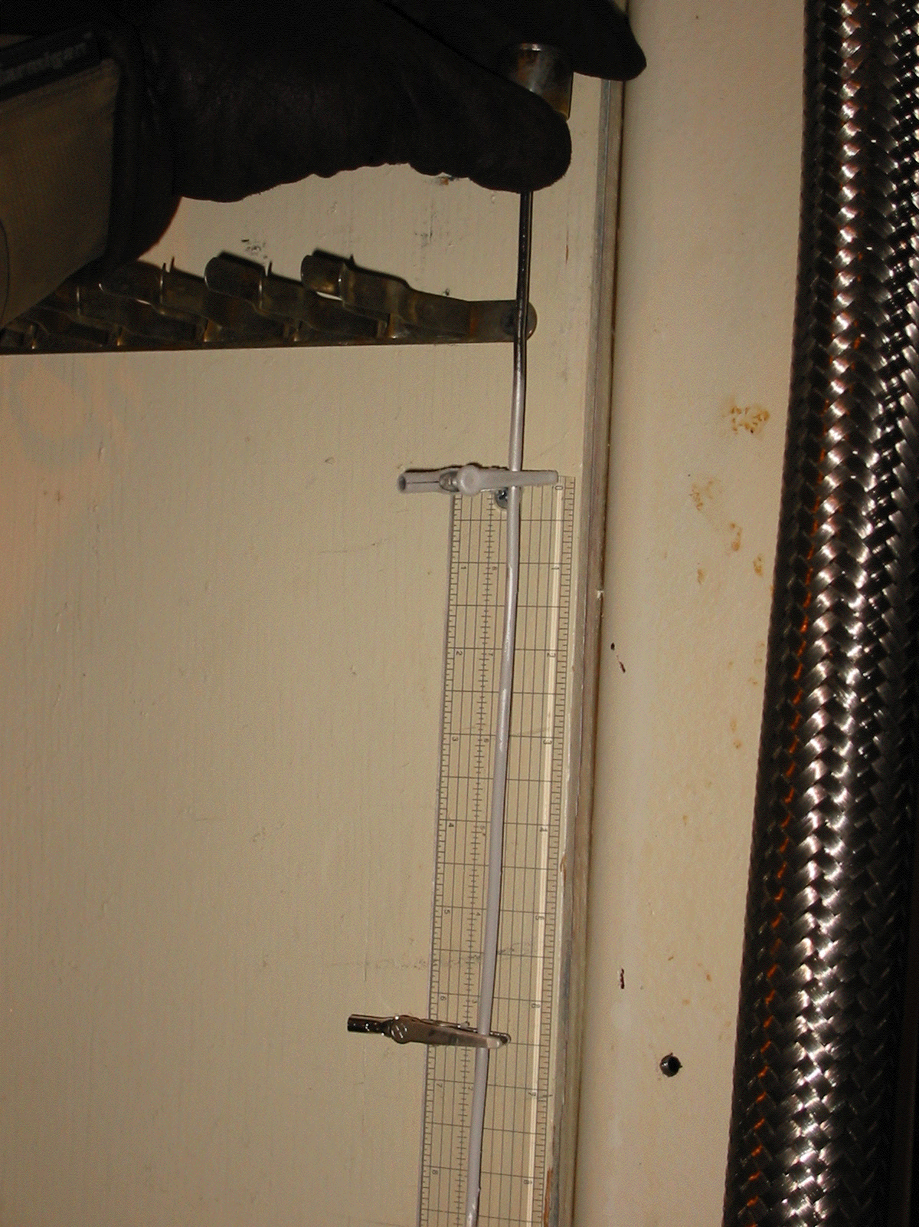

Person at SHARCII:
• To measure the level of He:
Remove the lower alligator clip from the small dipstick with a cylinder on the top and two alligator clips below; then insert the dipstick until you reach the bottom of the tank. Once you reach bottom, replace 1st alligator clip at the top of SHARC II’s LHe Tank. Slowly raise the dipstick and replace the alligator clip when you hear the frequency of the vibrations change significantly. Measure the distance in inches between two alligator clips and record the amount used on the clipboard attached to the tank.
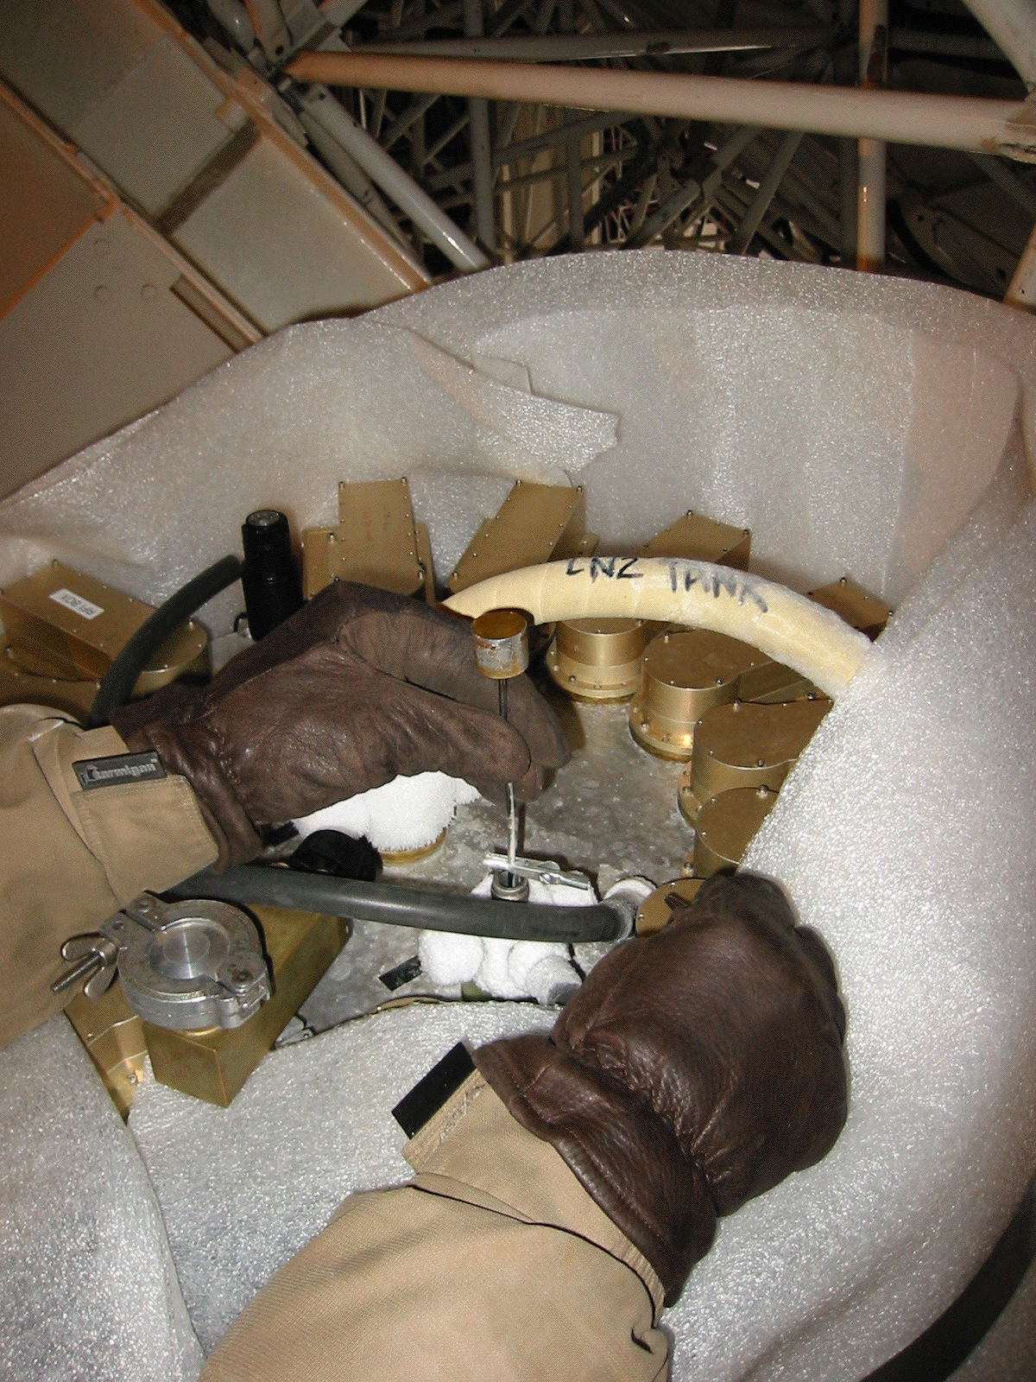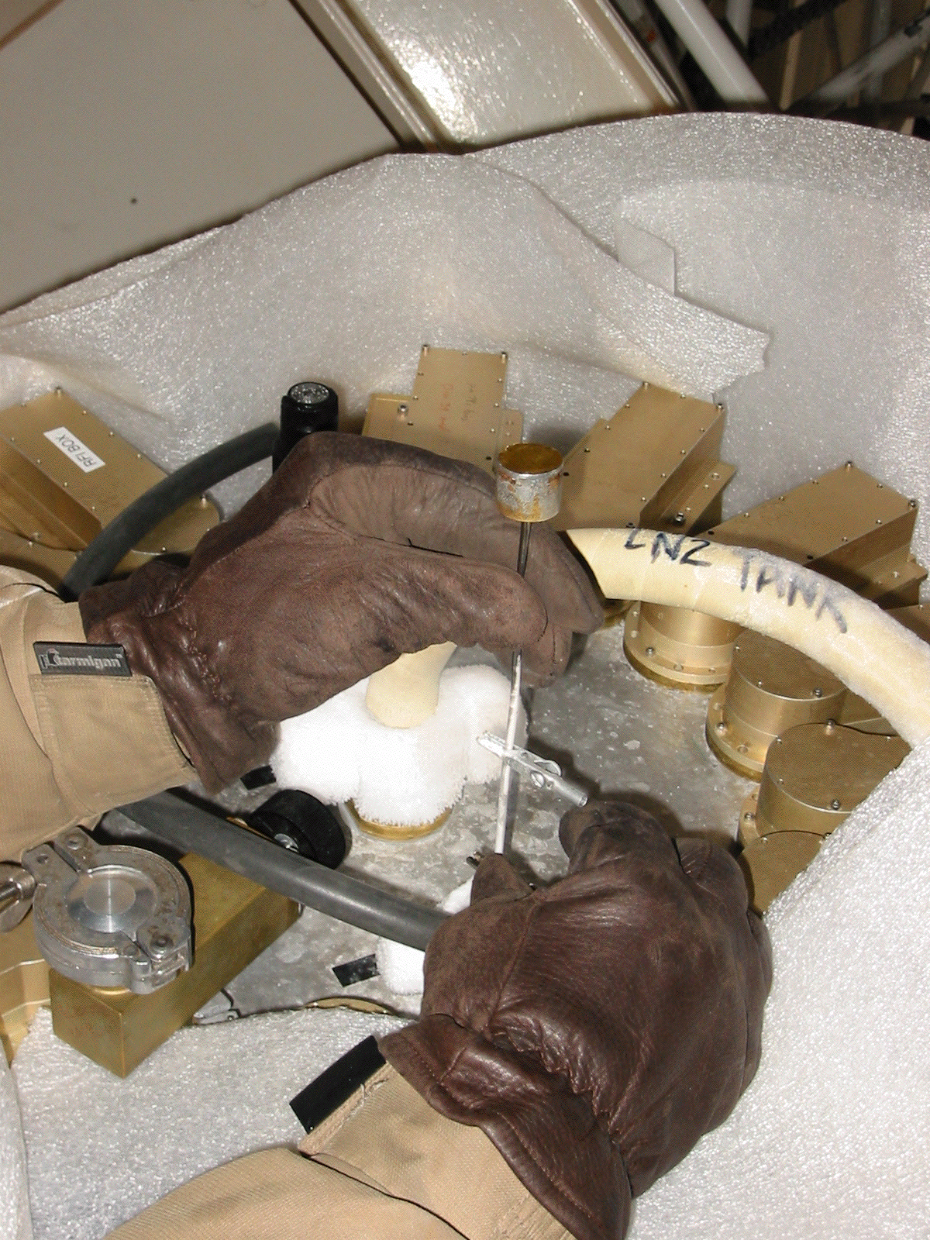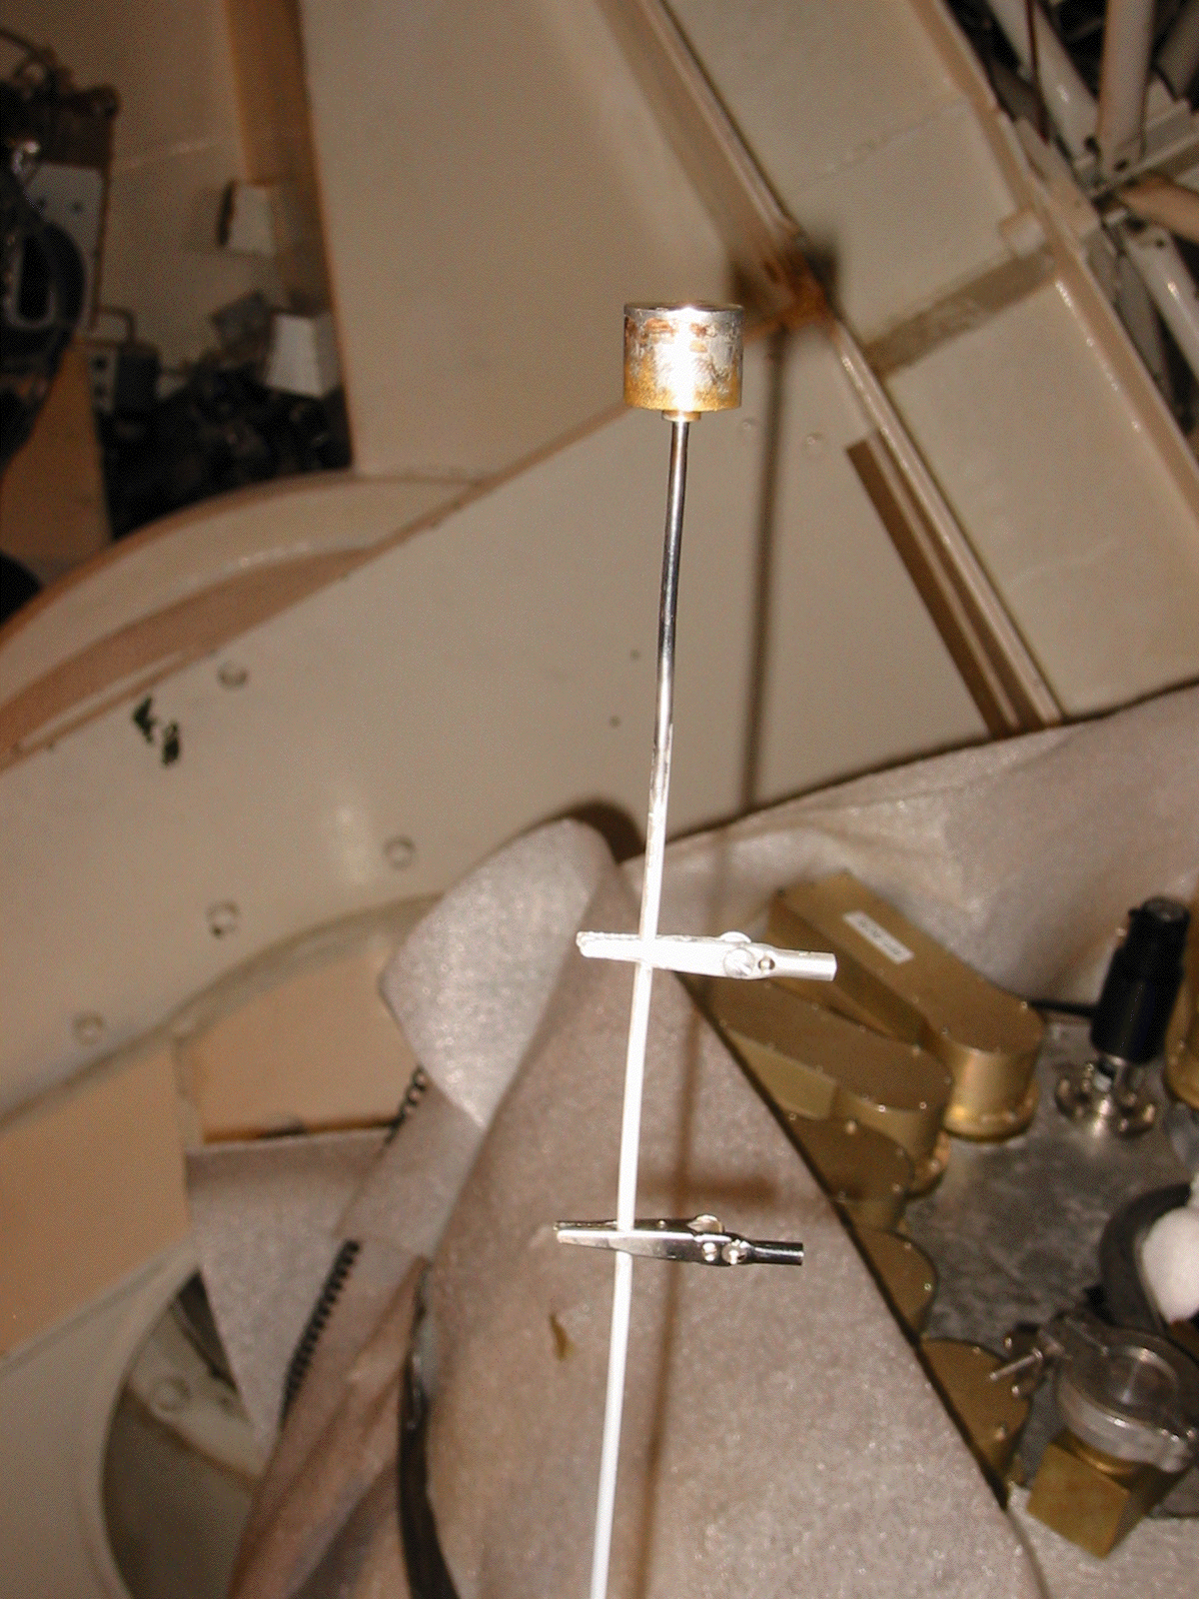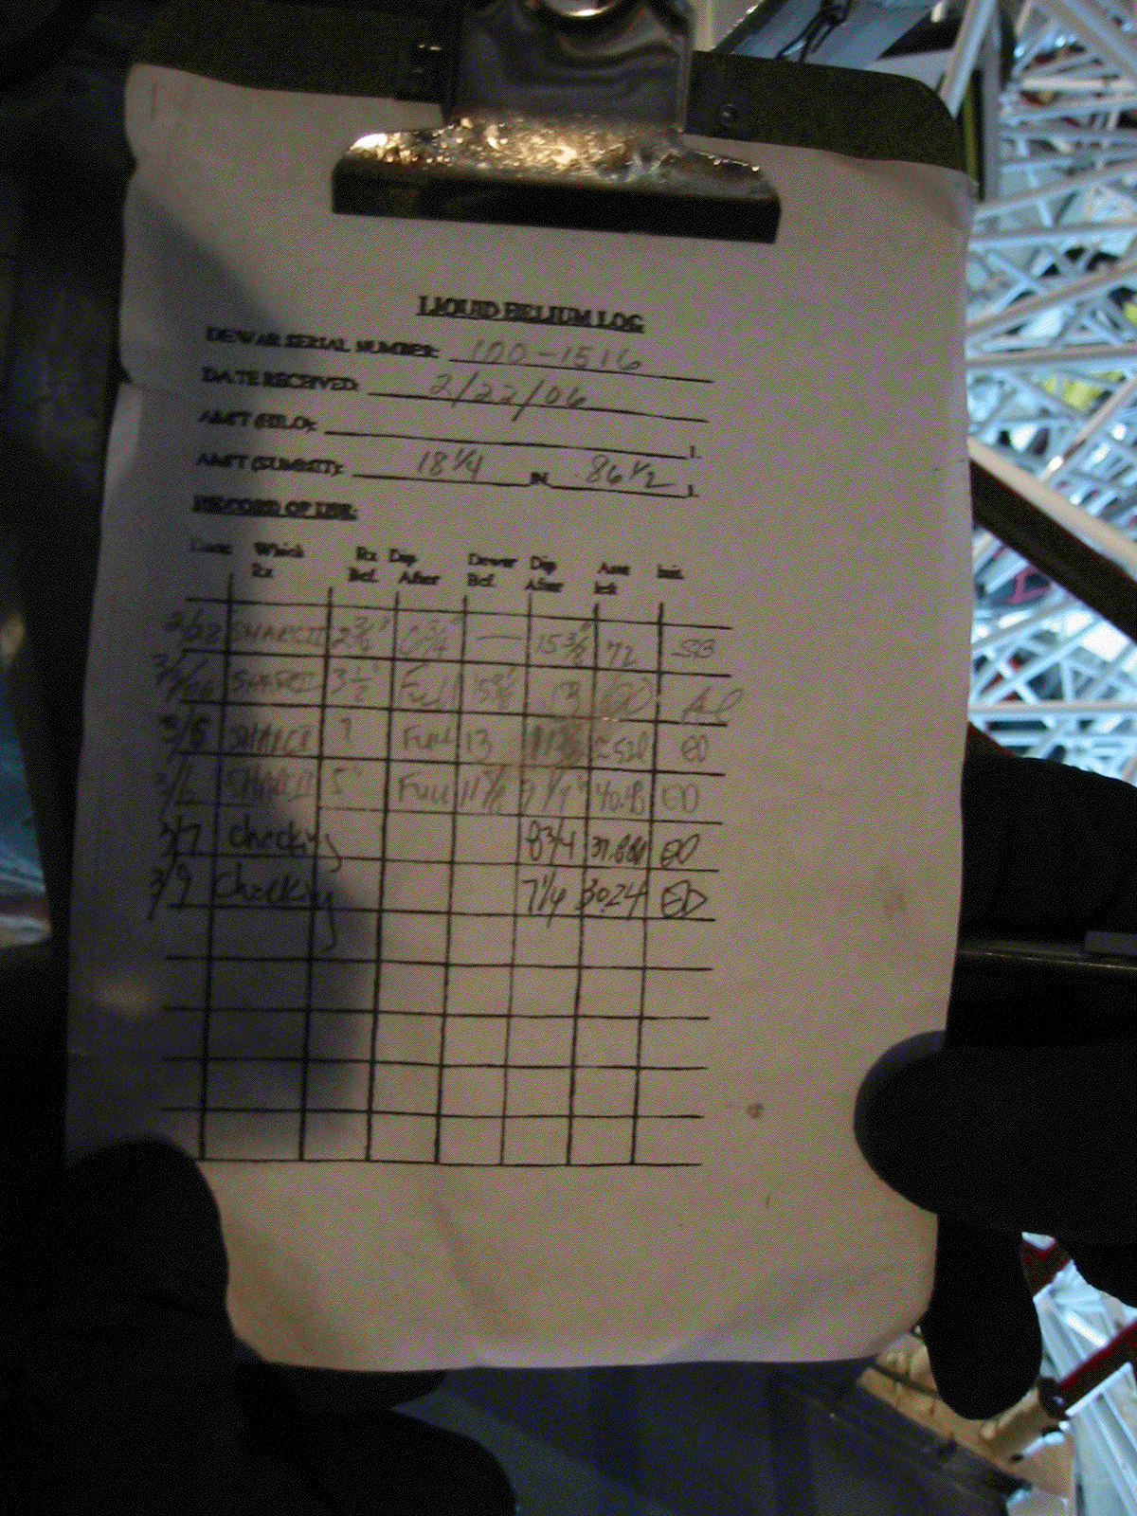
• Replace the black vent hose on the He port.

Final configuration of the He tank valves when the transfer is finished:

If there is no brass ring attached on the transfer tube you are going to use, try to find one on other transfer tubes. In case if you can’t find any, try to find one in the AOS room on the 2nd floor.

